R Plot Assignment

Team:

Janice Chan

Owen Henry

Vyjayanthi Kamath

Our project revolves around analysing the Kickstarter platform data that includes information about several campaigns hosted on it. Specifically, information like:

* ID
* Category
* Sub-category
* Number of backers
* Goal
* Pledged
* Status
* Currency
* Date launched

Data:

Kickstarter (2017), Kickstarter Projects (3) [Data file]. Retrieved September 10, 2018, from <https://www.kaggle.com/kemical/kickstarter-projects>

The source file for our Kickstarter Data Analysis was taken from kaggle.com, under a Creative Commons BY-NC-SA 4.0 license. This means that, as long as we provide the appropriate attribution, do not use the data for commercial purposes, and share our work under the same license, we are free to share and adapt the dataset.

Plots:

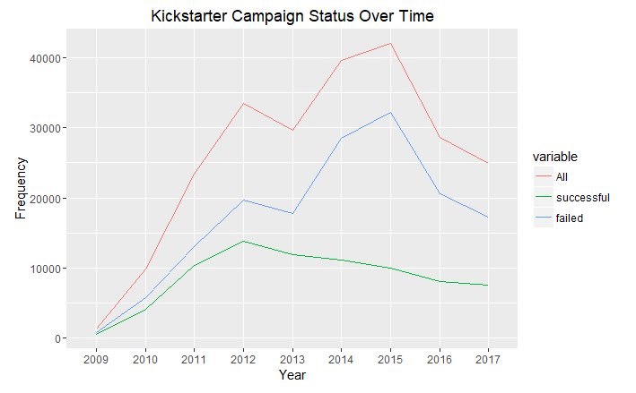

The above plot shows a line graph depicting the status of the Kickstarter campaigns from 2009 through 2017. The x axis is the year and the y axis shows the count. The status of a particular campaign is the final outcome of the campaign, i.e. successful, failed, or cancelled.

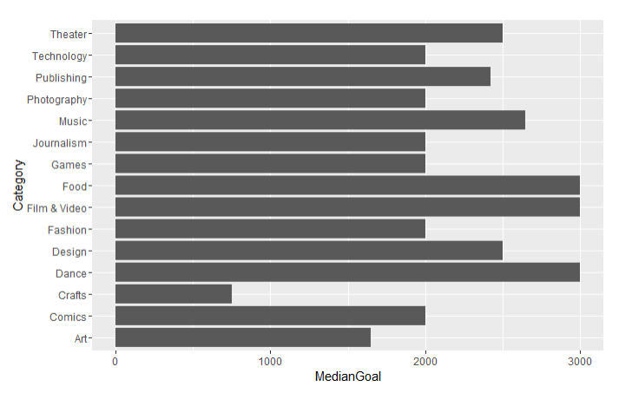In order to get an idea of the Pledged amounts, number of backers and the Goal amounts, we ran several plots to analyse the descriptive statistics of the concerned variables

Figure 2

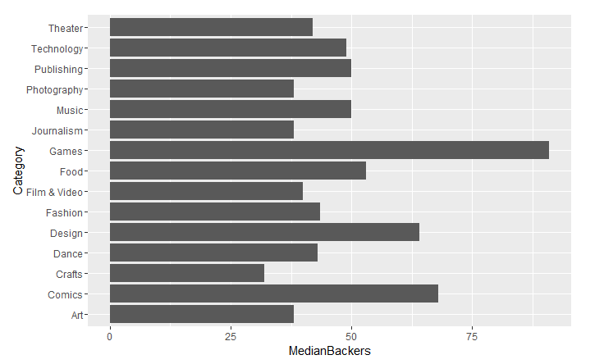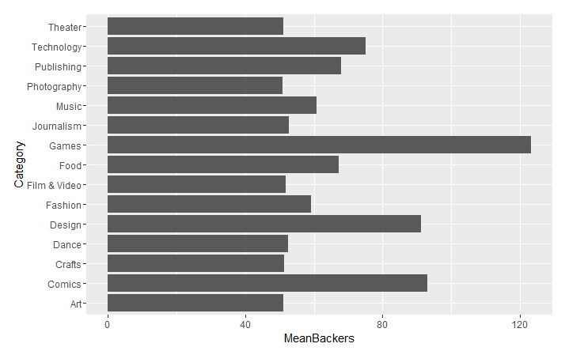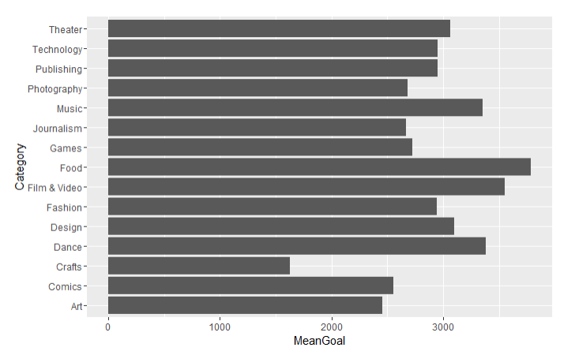

Figure 5

Figure 4

Figure 3

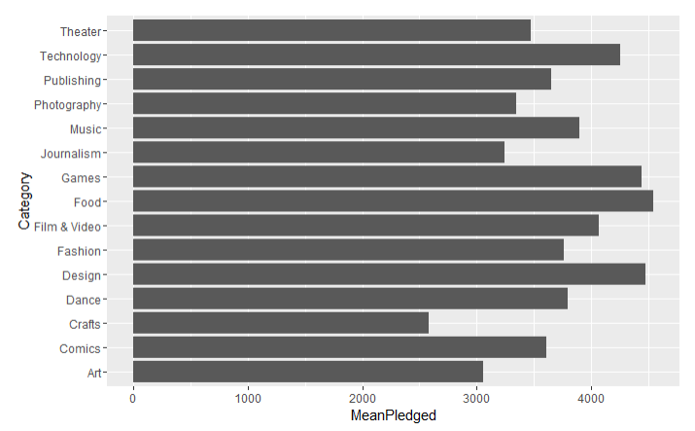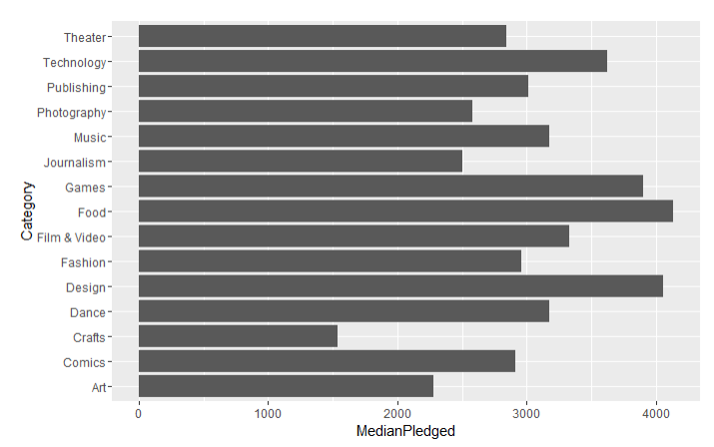Figures 2 and 3 are used to take a look at the average and median goal amounts of the campaigns, category wise. This way we can get an idea of the category that can be deemed as “financially demanding”.

Figure 7

Figure 6

Figures 4 and 5 describe the mean and median number of backers required category wise. This way, we know what categories on the Kickstarter platform seem to be popular with the backers and how many they can attract to fund their campaigns.

Similarly, Figures 6 and 7 describe the situations of the amounts pledged for the campaigns. These plots can be compared with the plots that describe the Goal amounts to analyse what categories reach their Goals on an average.